**Deep Learning**

**Basic theory**

**Activation (non-linear)**

Meaning – add non-linearity to the model. In a lot of cases the correct hypothesis is non-linear and could not be learned without non-linear activation.

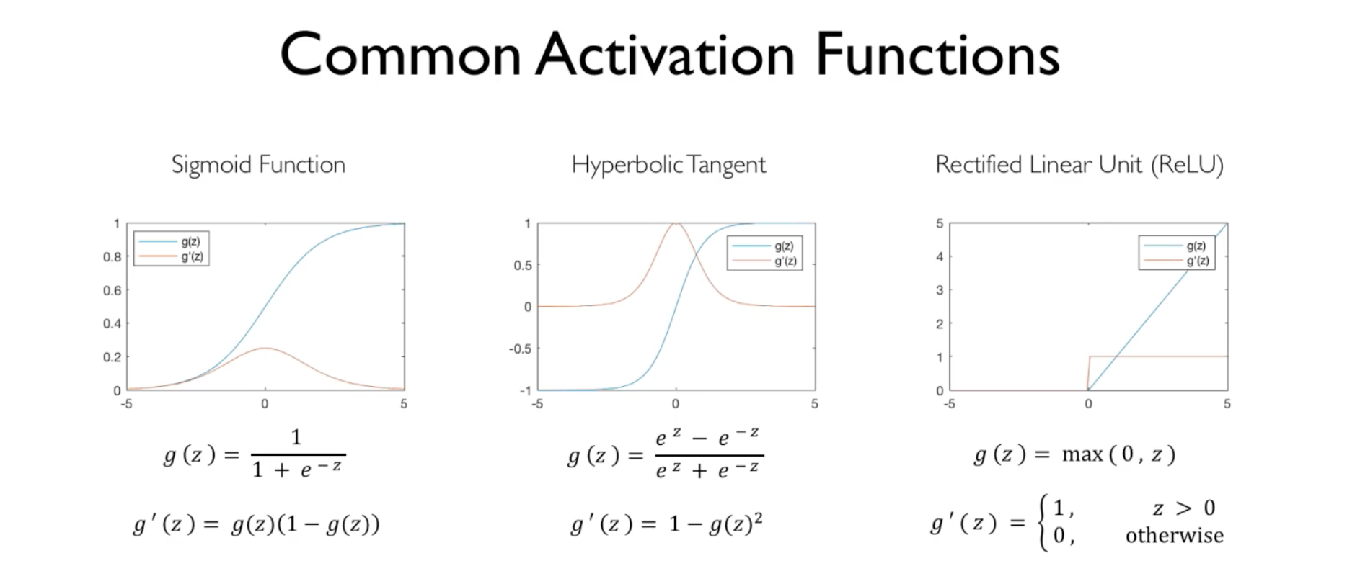

**Perceptron**

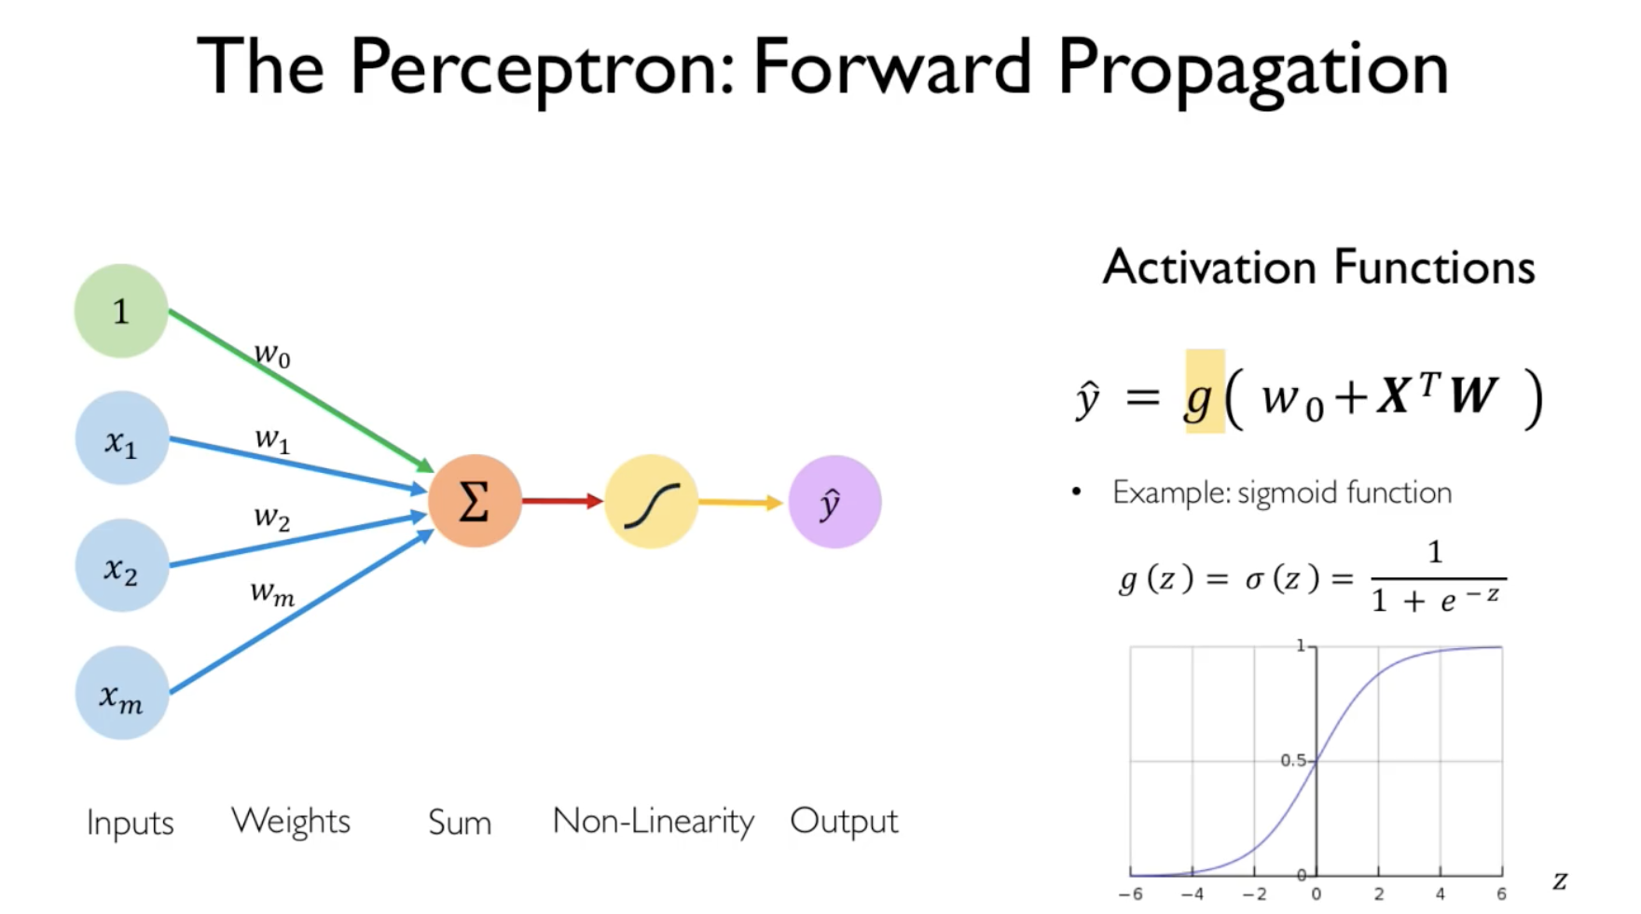

**Multi-layer neural network**

Connection between multiple layers of perceptrons.

**Loss function + training**

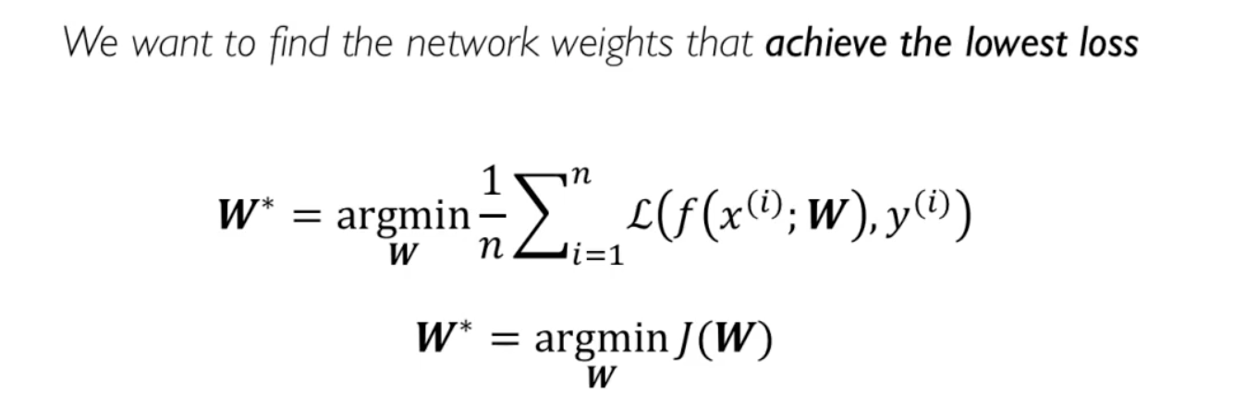

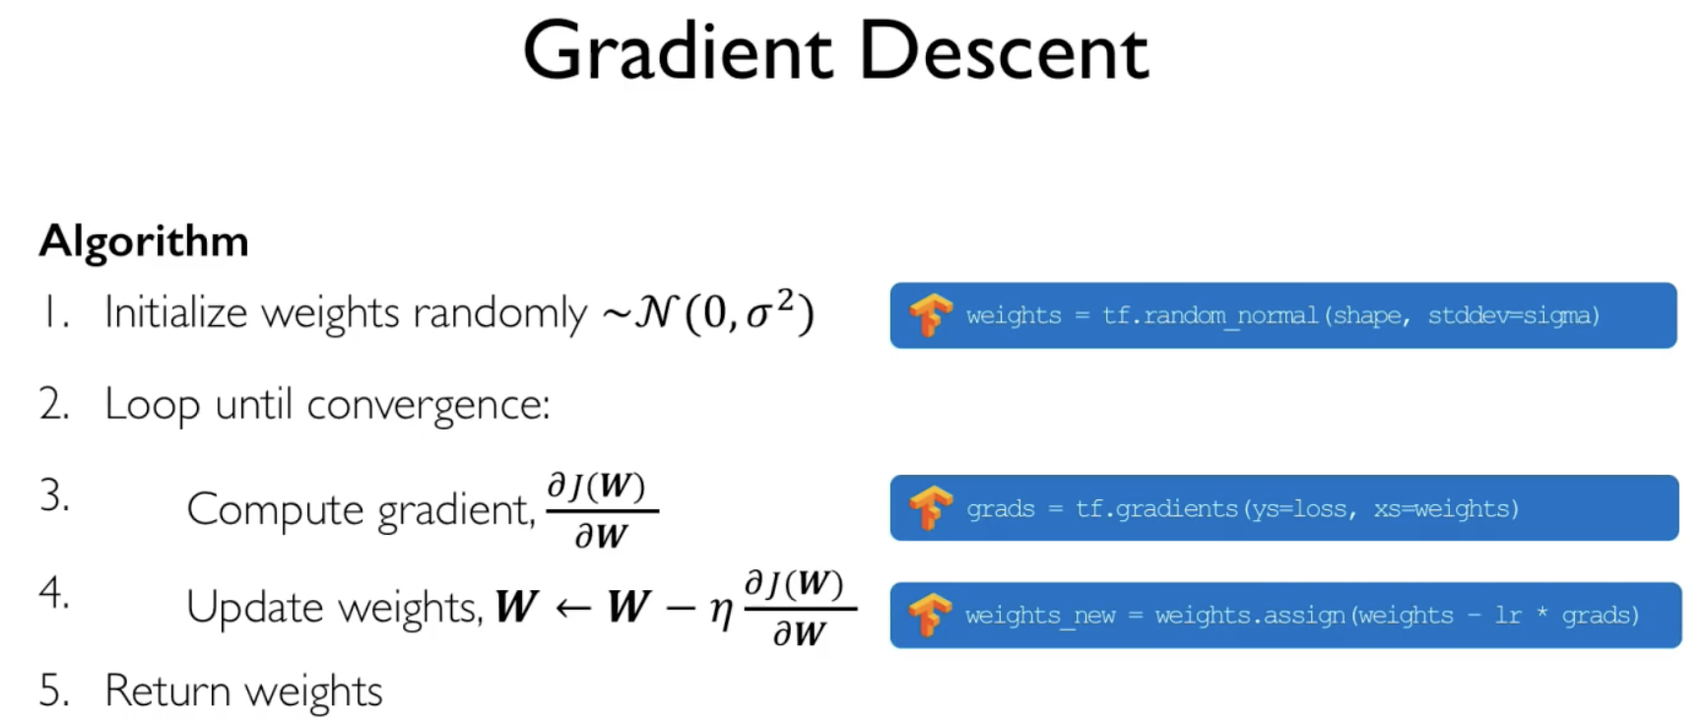

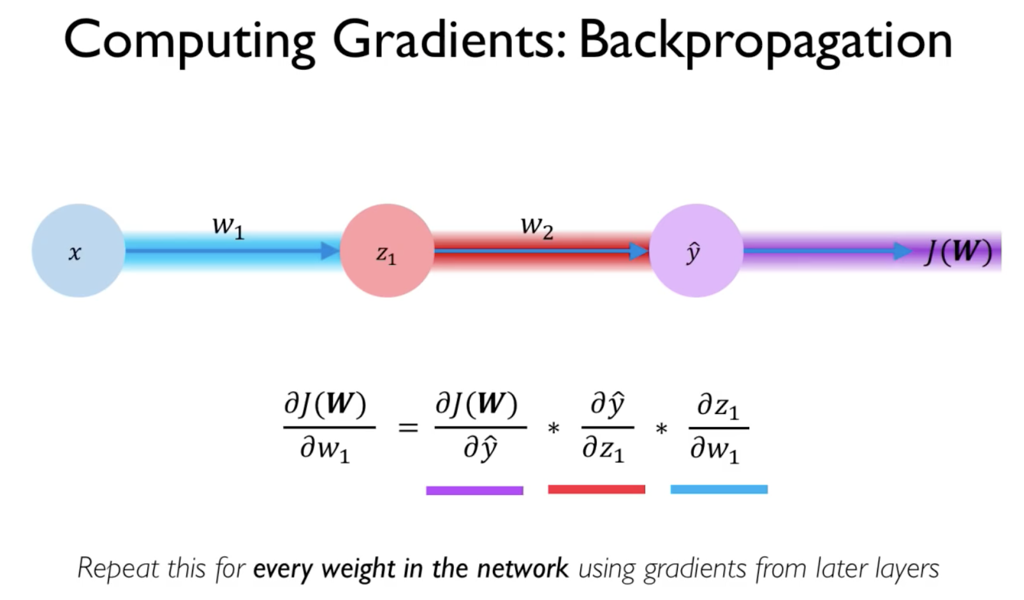

**Optimization – adaptive learning rate**

The optimization function is highly non-convex and hence could be stuck on local-minima. We can change the learning rate in G.D during the learning process according to the gradient magnitude, size of weights etc.

**Batch gradient descent**

Instead of calculating the gradient based on the error on the entire data set, in every GD iteration:

SGD – calculate gradient based on a single data point

Mini batch GD - calculate gradient based on a group of data points

**Regularization – avoiding overfitting**

We want a good generalization. No overfitting and no underfitting. To make the NN not to learn too complex model there are some regularizations techniques:

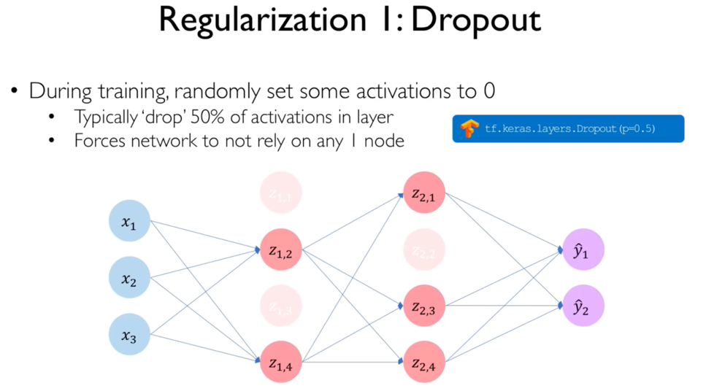causes the final solution to be like an ensemble of paths. The training with dropouts causes the NN to learn multiple paths for a good solution and when all neurons are active, the ensemble will “gather”

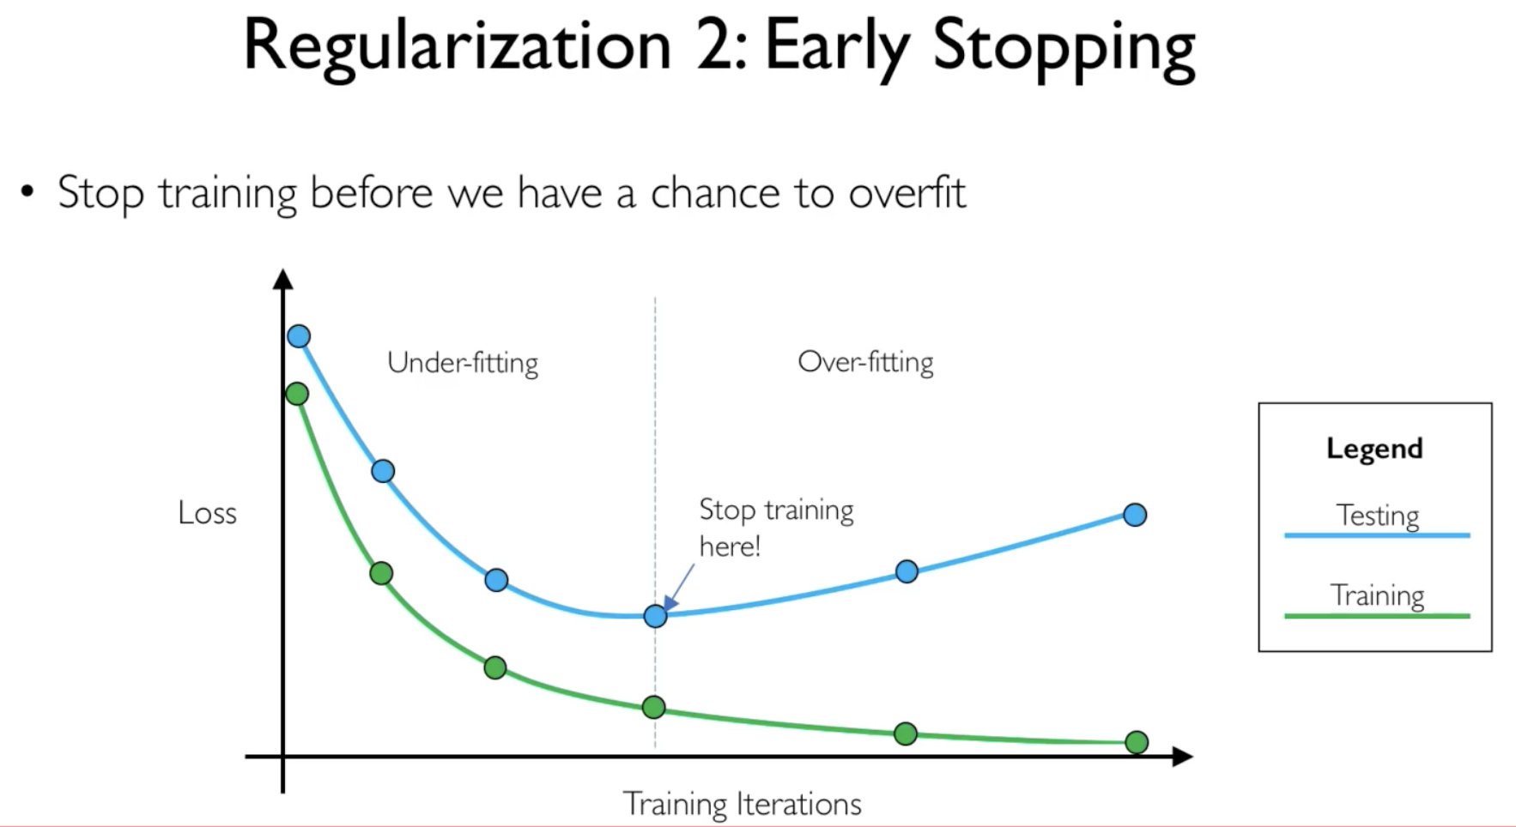

**Recurrent neural networks (RNNs)**

When we have a task of sequence modeling - predicting the next element in a sequence, we will use Recurrent NN (RNN).

|  |  |
| --- | --- |
|  |  |

At each step, given an input x, the output y will be computed using h(t), the previous state of the network. Also, it will update h(t) for the next iteration. In that way, the system can benefit from previous inputs and sequences.

We will have 3 sets of parameters:

* $W_{hh}$ for the h update based on previous h
* $W_{xh}$ to update h based on the current input
* $W_{hy}$ to calculate the network output.

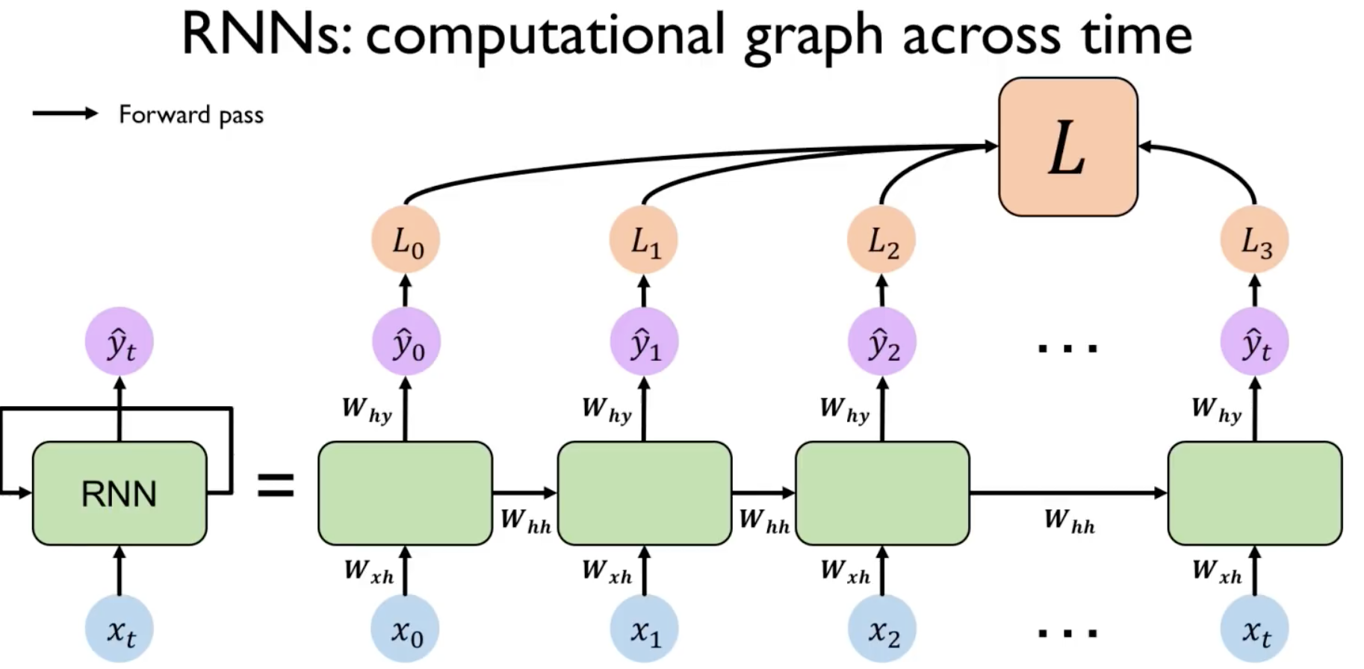

**Train RNNs**

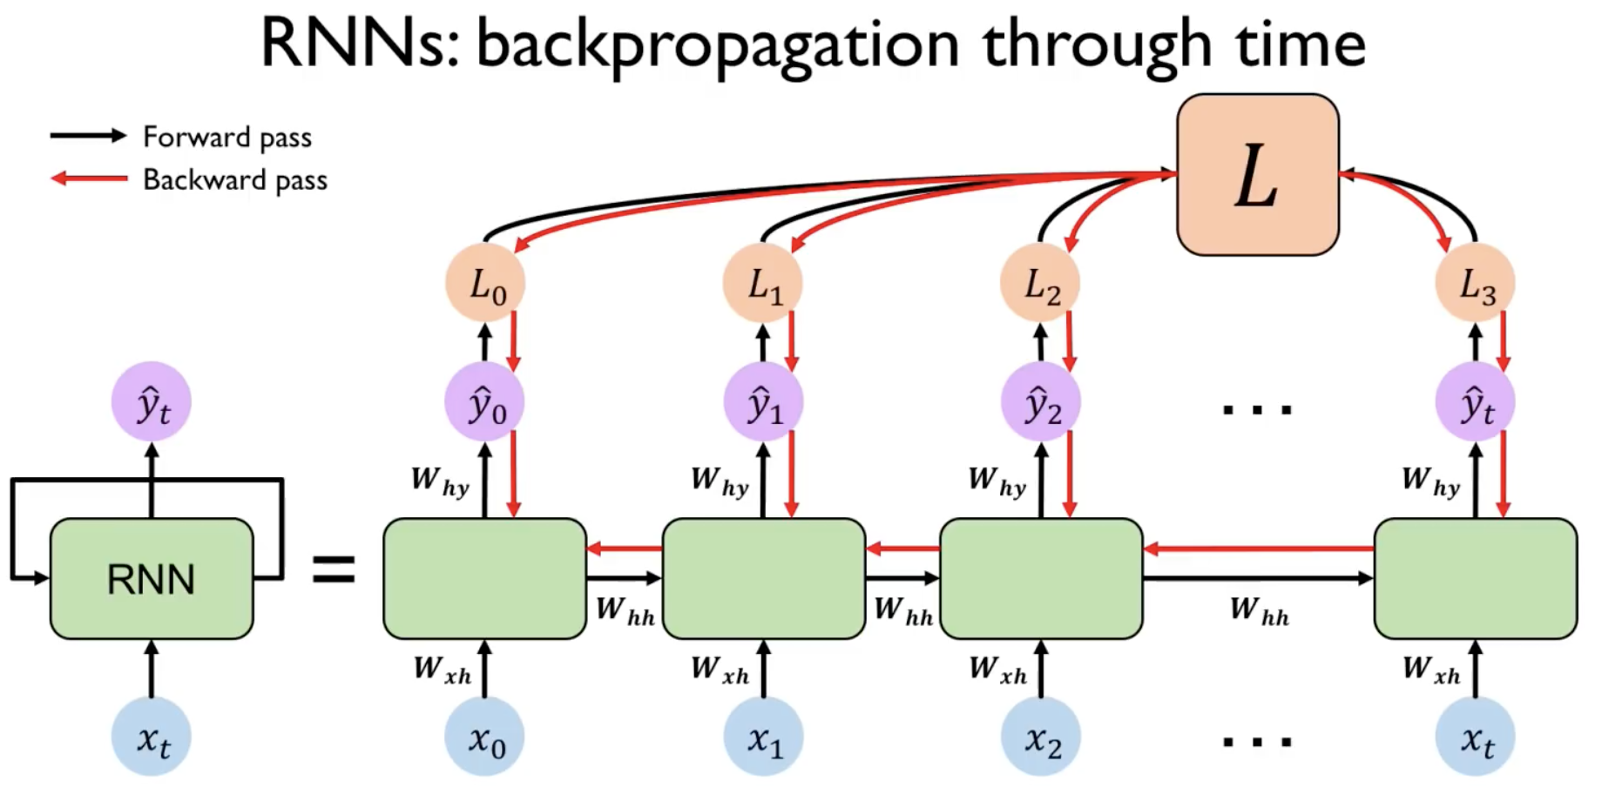

**Convolutional Neural Networks:**

An NN architecture that consists two main parts: feature learning as the first part and classification in the second.

* Feature learning - this model can learn a hierarchy of features: in the first layers, low level features will be learned and in the last ones, high level features. The convolution takes advantage of the spatial relationships in images.
* Classification – by the end of the above there is a concise features map that feeds a NN model that is being used for classification.

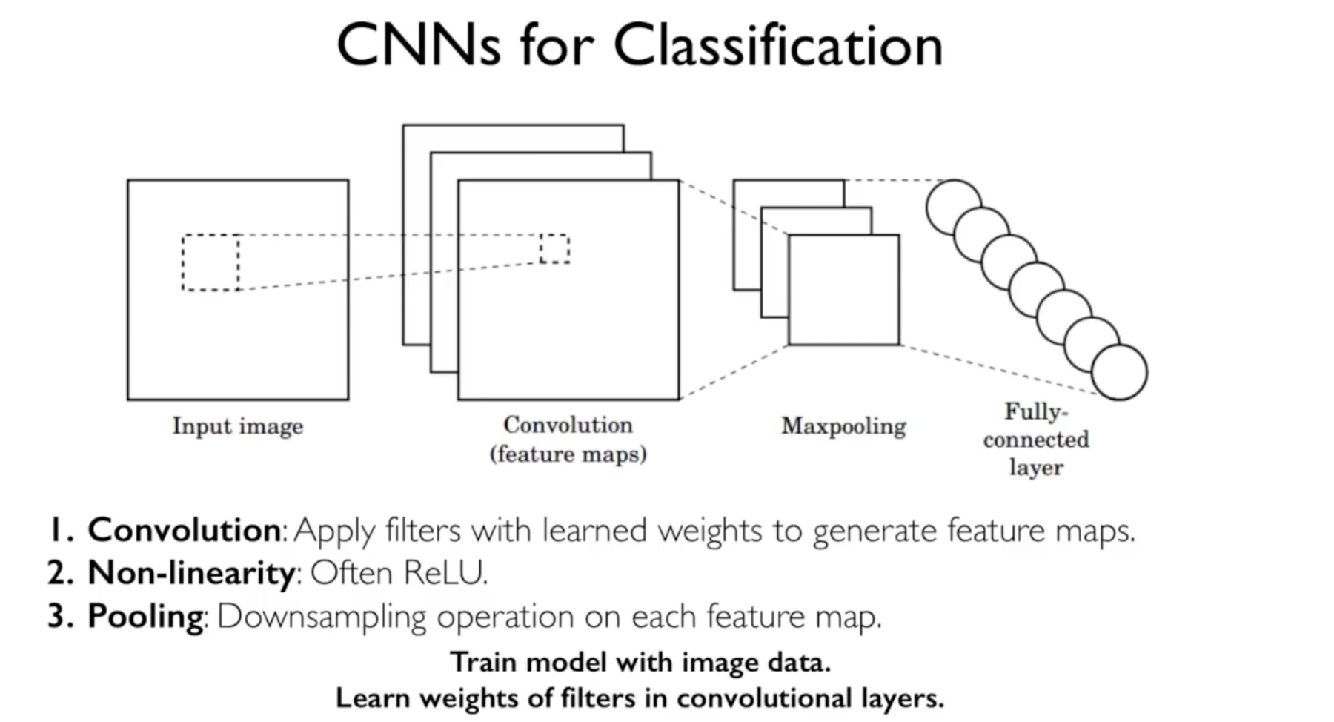

Convolution step in CNN

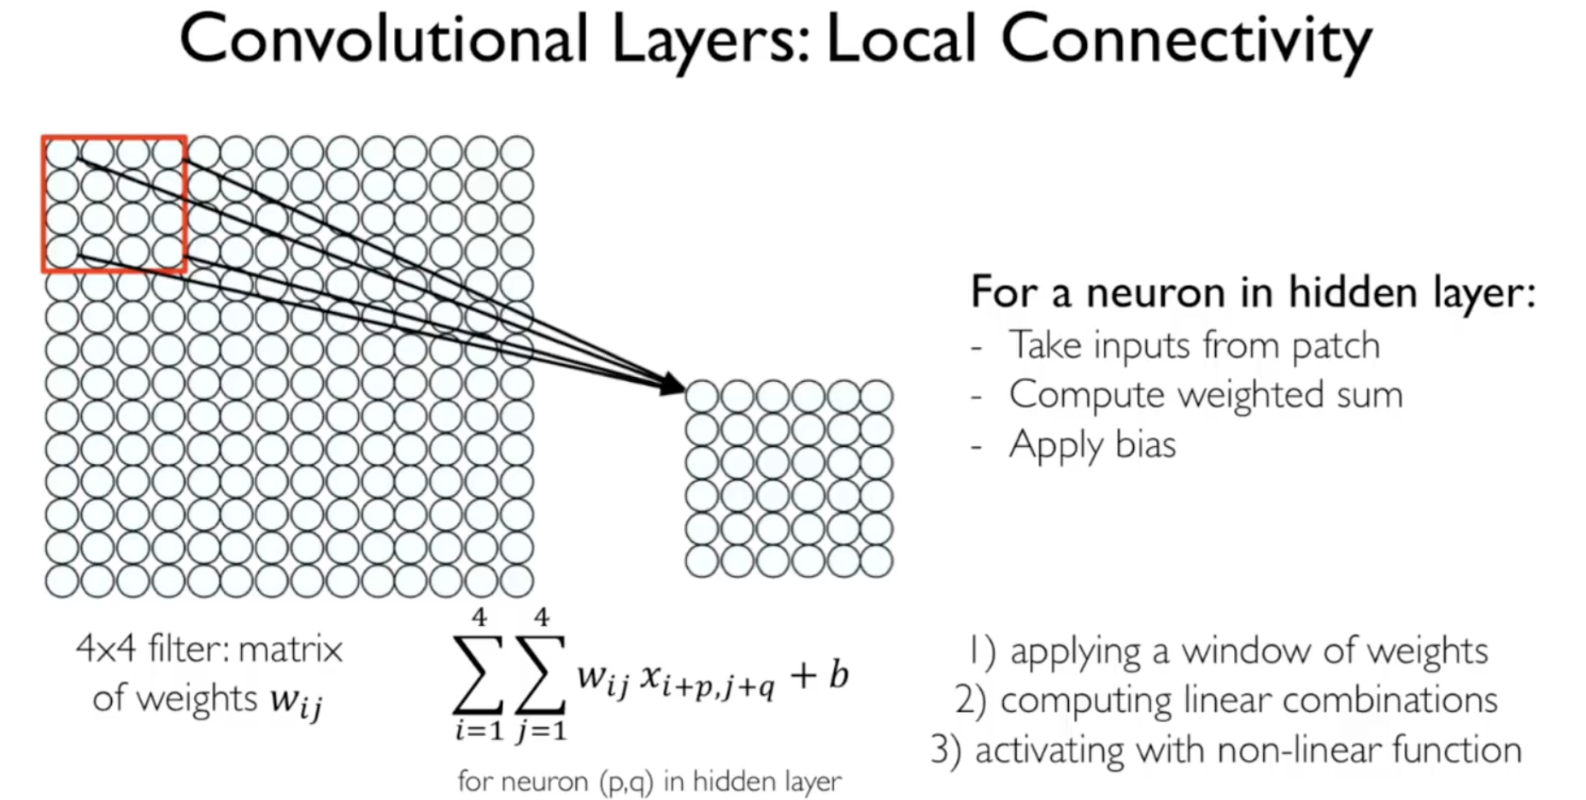

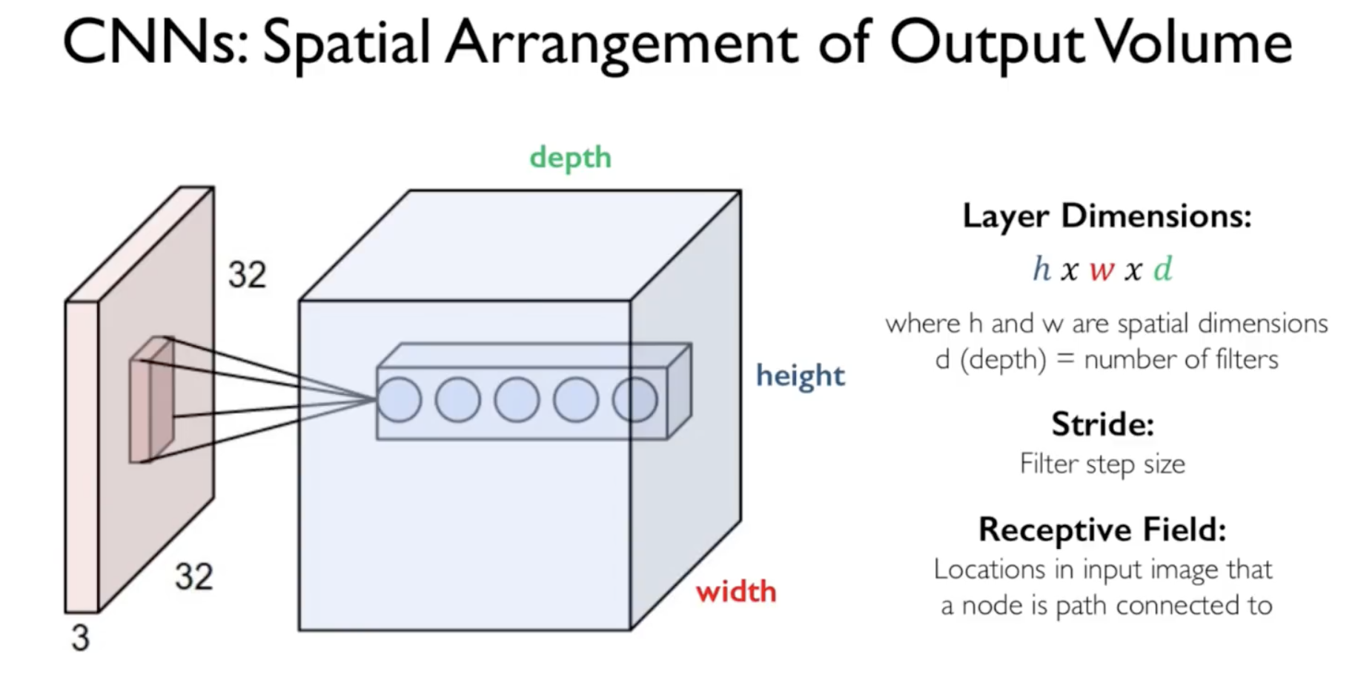

Non-linearity

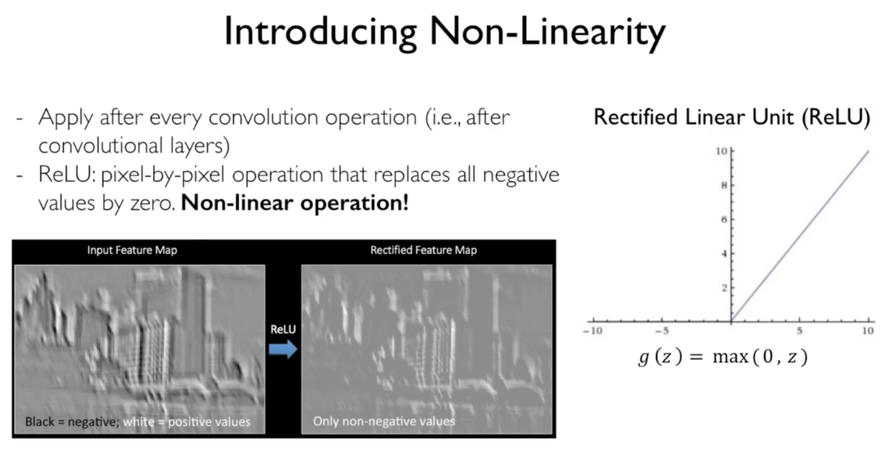

Pooling

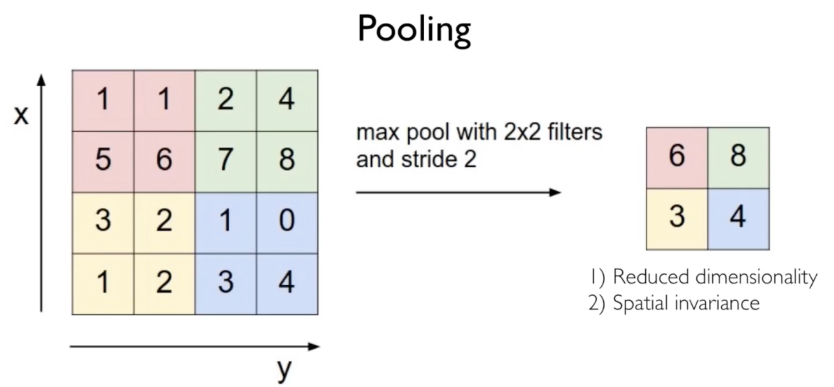

Complete architecture and training

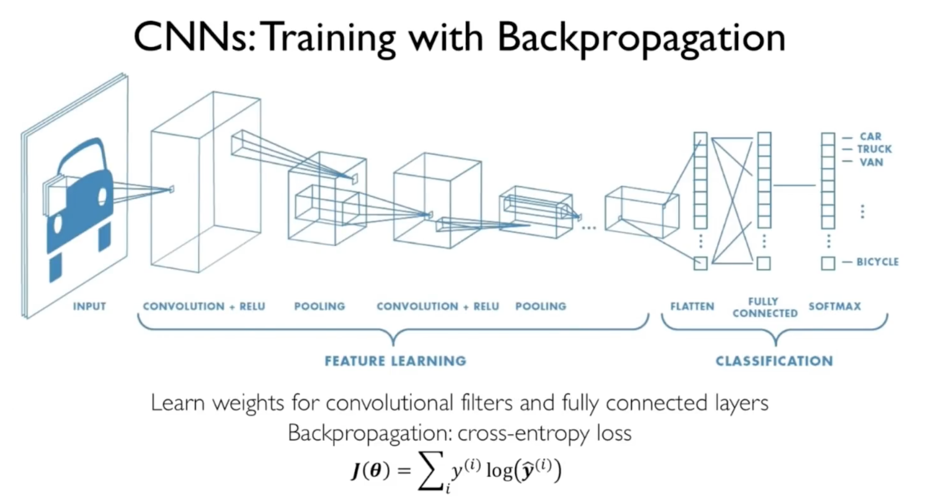

**Deep generative models:**

Autoencoders

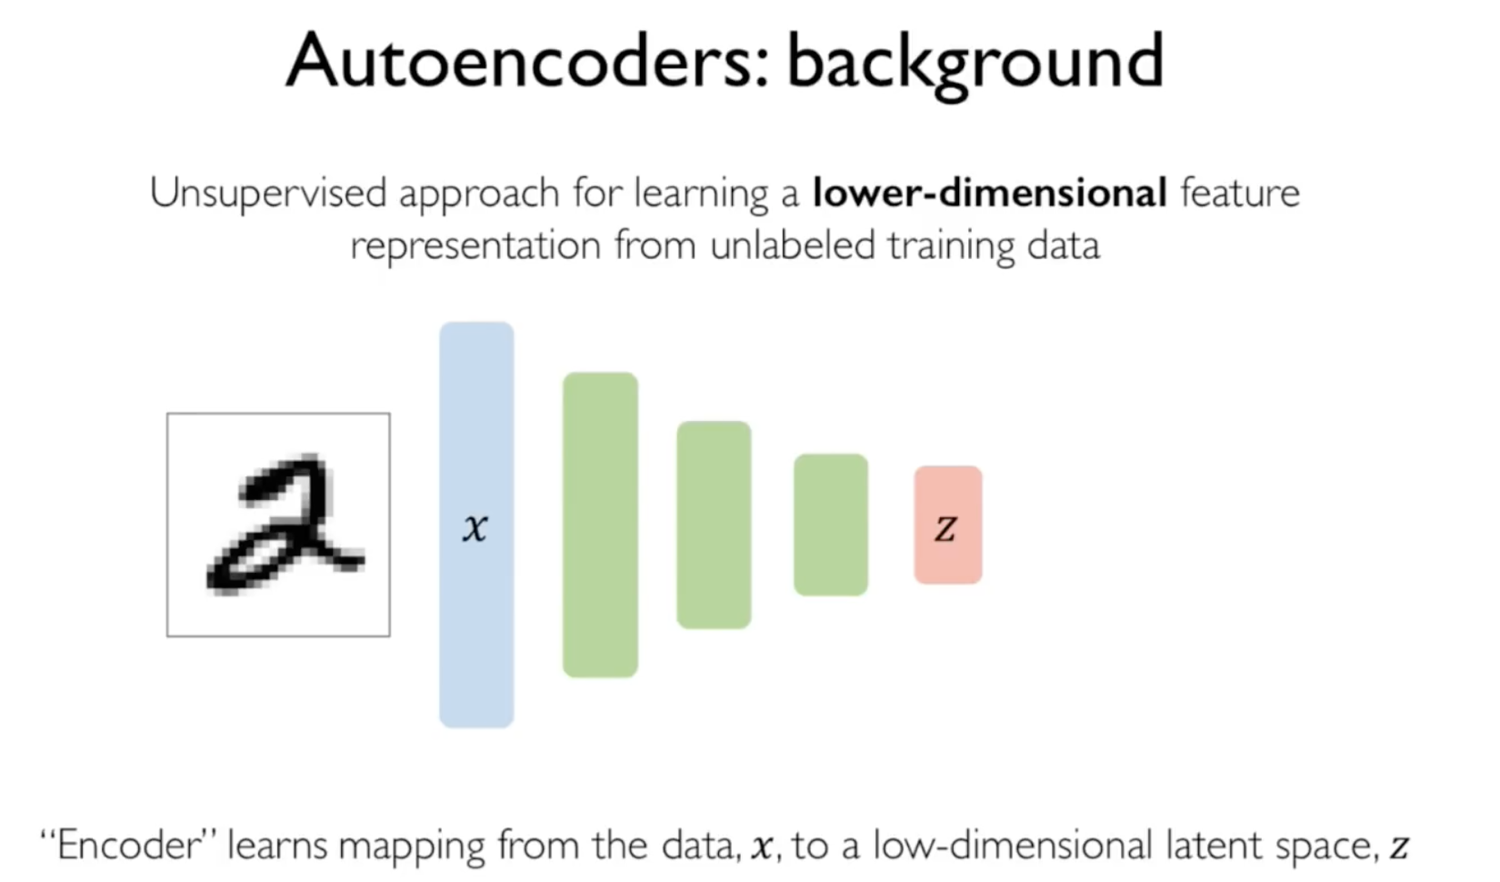

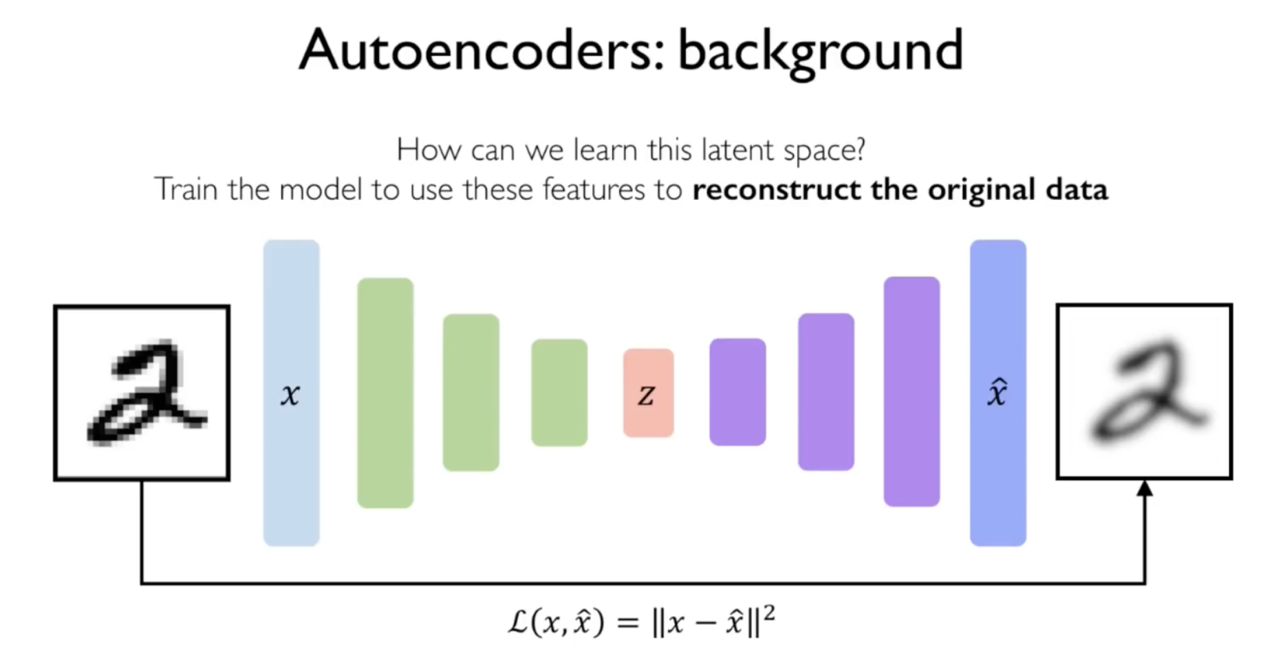

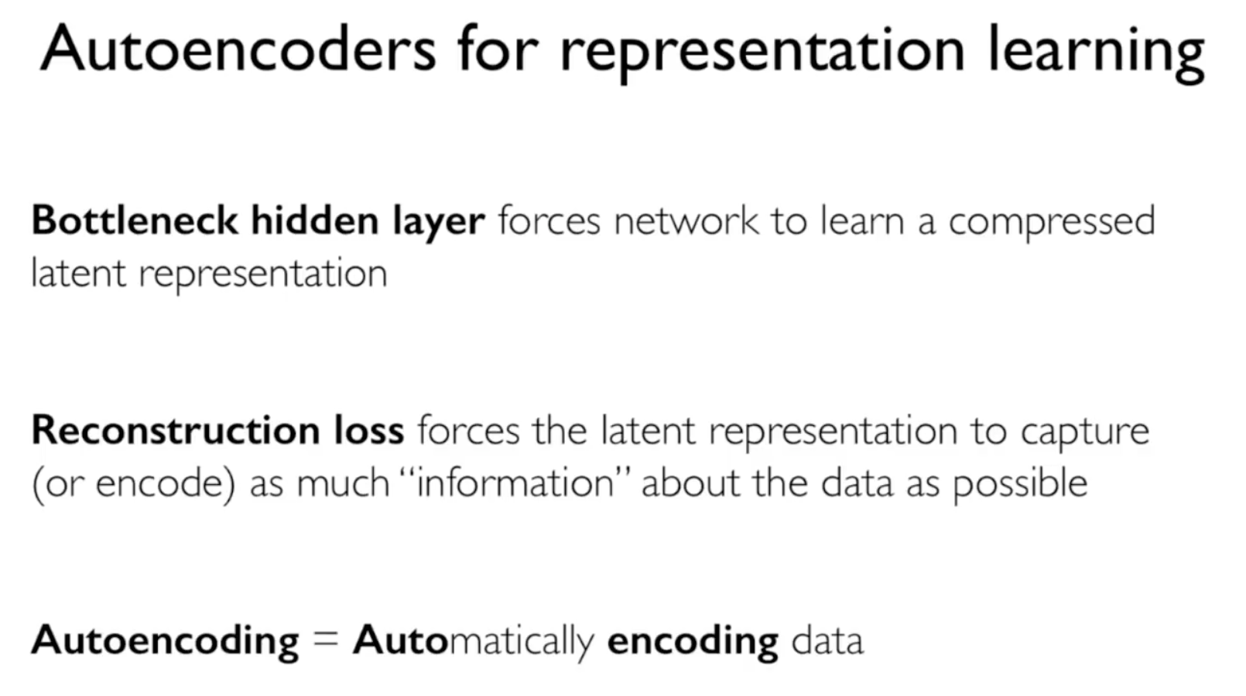

Variational autoencoders

the above approach is deterministic – given the same input, the same latent z will be generated and hence, the same output. If instead of a deterministic value z, we can learn its probabilistic features – mean and std. now, we will draw its value from the distribution and get different outputs.

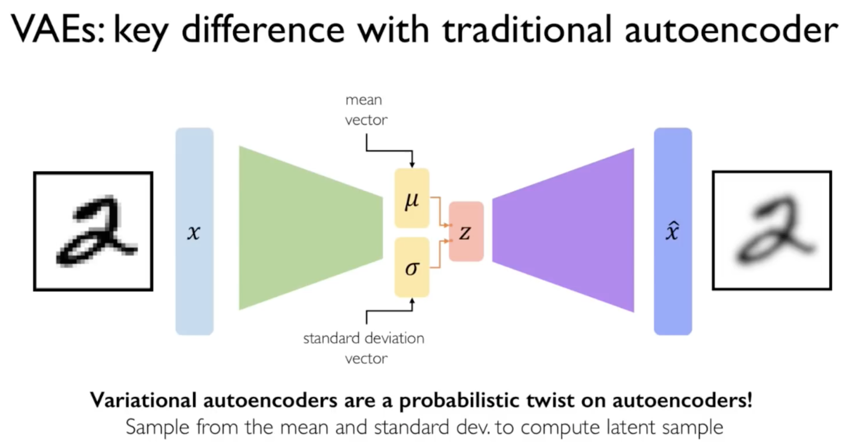

Generative adversarial networks (GANs)

Goal – generating outputs.

